# Learning Journal Week 3

Today I have learned how to work with CMS by watching videos on Youtube and teacher Lindsay at JCU University. By going over the basic of CMS that I have learned how to make home, about and contact pages:

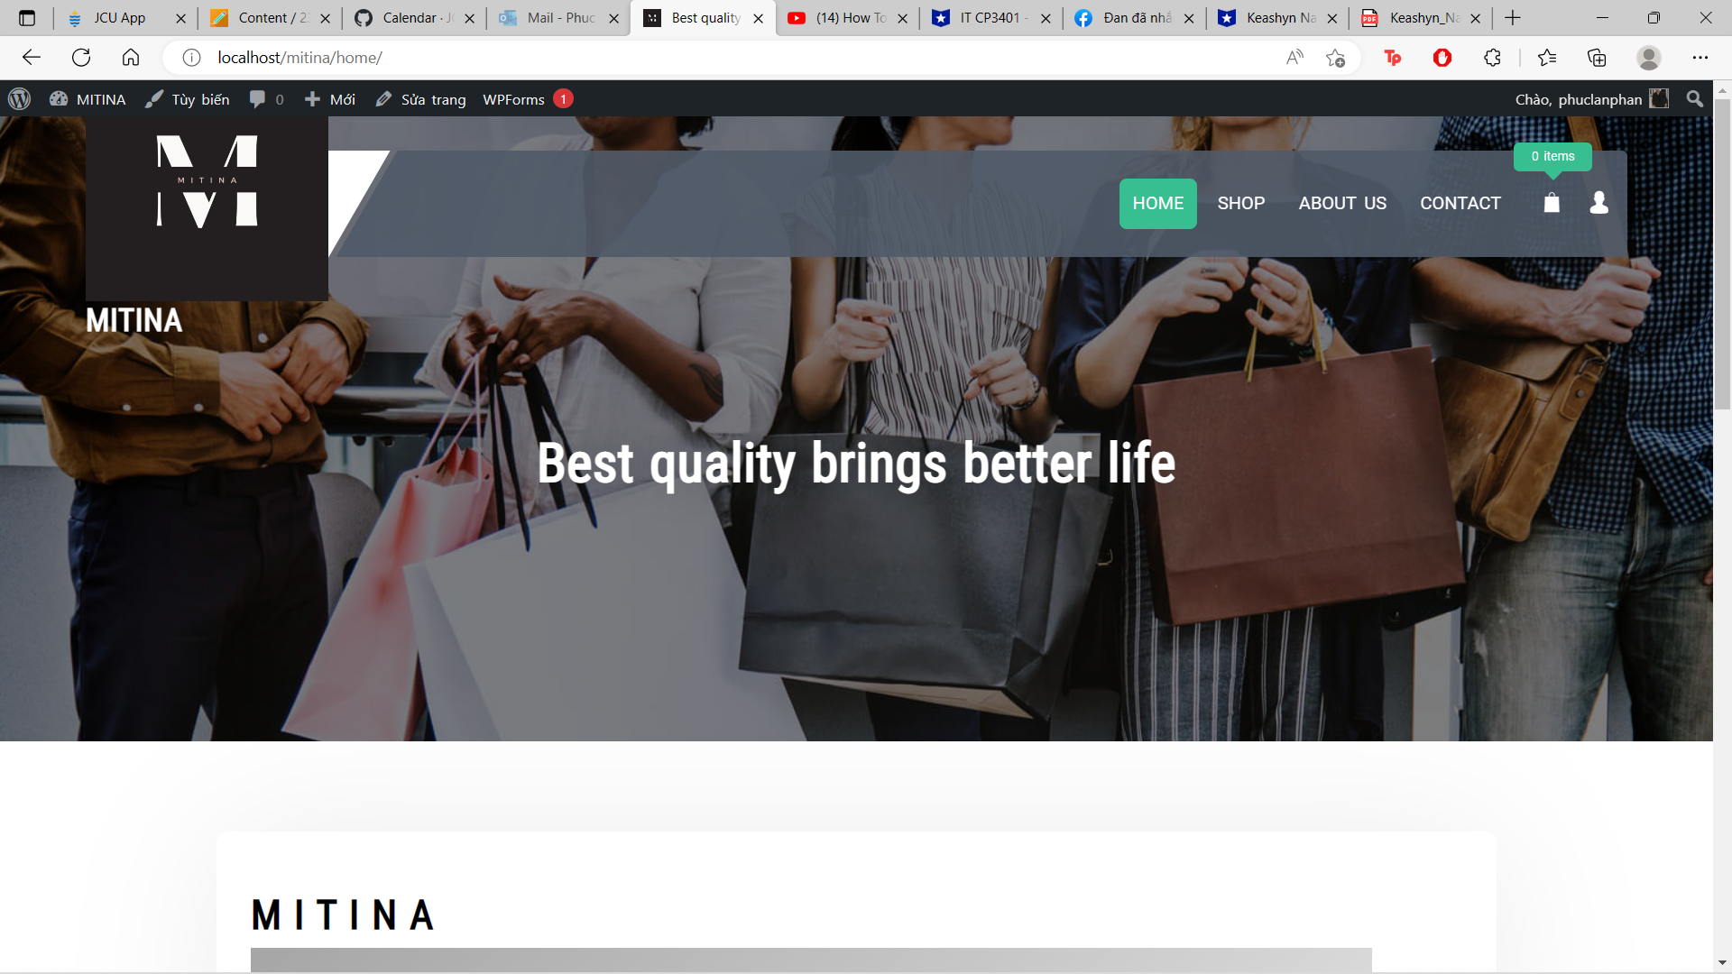

Home page

Contact Page

About Page

## Estimate working hour

Since I started from zero, I need to go all from the beginning. Around more than 2 days of exploring and practicing WordPress so that I can make my own website, MTINA, although it is not completed.

## Sources

Video on JCU learner of teacher Lindsay doing WordPress Demo.

[(13) How to Setup a Homepage in WordPress - YouTube](https://www.youtube.com/watch?v=ePA6fCiLQc0&ab_channel=WPVenture)

[(13) How To Build A Website in 20 Minutes (Wordpress Tutorial 2023) - YouTube](https://www.youtube.com/watch?v=oX3lgJoj27g&ab_channel=SantrelMedia)

[(13) How to create contact form in wordpress 2023 - YouTube](https://www.youtube.com/watch?v=ot5Rngs1pts&ab_channel=HowTo1Minute)

[(13) How to Create Contact Us Page in WordPress | Using Contact Form 7 & Elementor - YouTube](https://www.youtube.com/watch?v=su7Qz-mzEJg&ab_channel=ErudienceIT%26Solutions)

[(13) How To Make a WordPress Online Store - 2022 - YouTube](https://www.youtube.com/watch?v=facMcbWB0jI&ab_channel=TylerMoore)

[(13) How To Create An eCommerce Website With Wordpress 2023 -ONLINE STORE- (Easy For Beginners) - YouTube](https://www.youtube.com/watch?v=TDNGEFd-aEE&ab_channel=DarrelWilson)

[(13) How to Create an eCommerce Website with WordPress FREE – ONLINE STORE 2022 - YouTube](https://www.youtube.com/watch?v=eaUi2Ri9wHo&ab_channel=NayyarShaikh)

## Learning Insight

It’s difficult to get familiar with the tools in WordPress. With the previous week experience, I did the work as that video was playing. Because both Joomla and WordPress are going to be done for the assignment 1 as well, I need to be more confident to deal with the tools in Joomla and WordPress CMS applications.